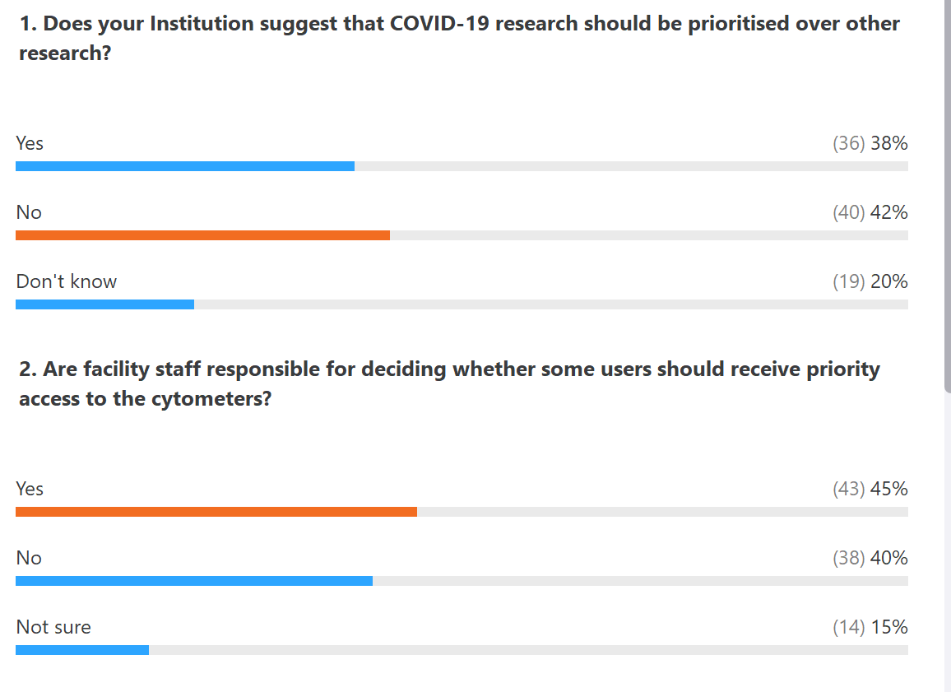
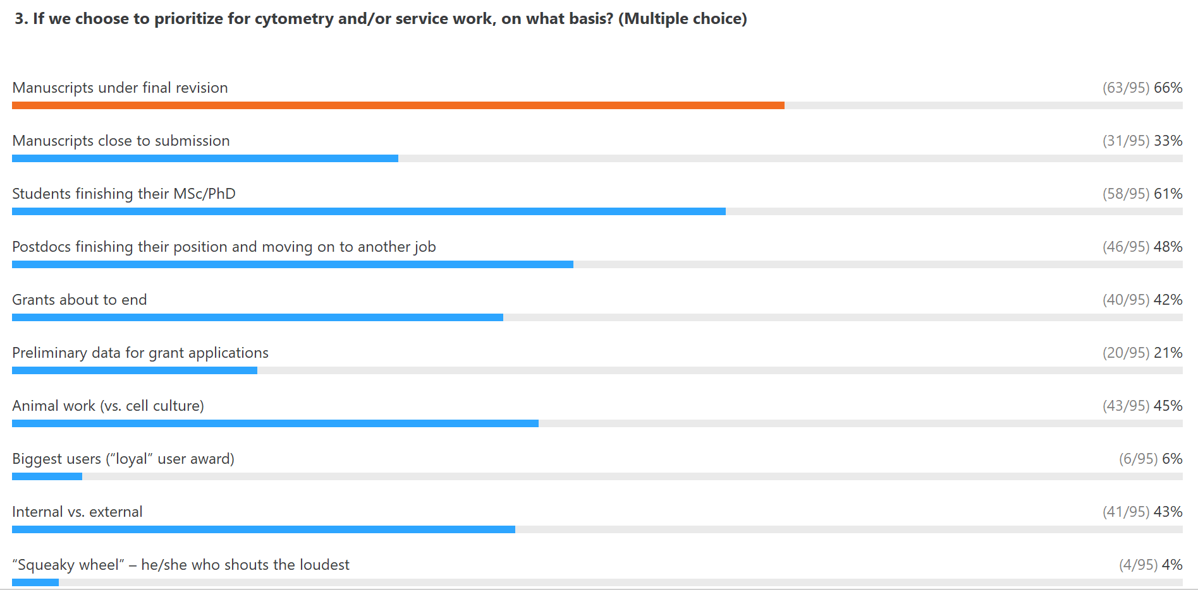
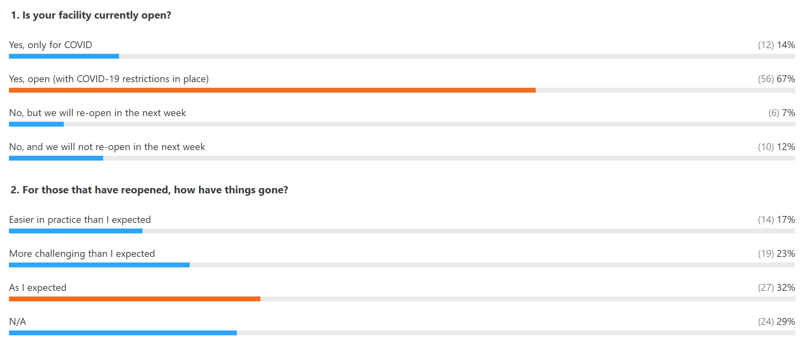
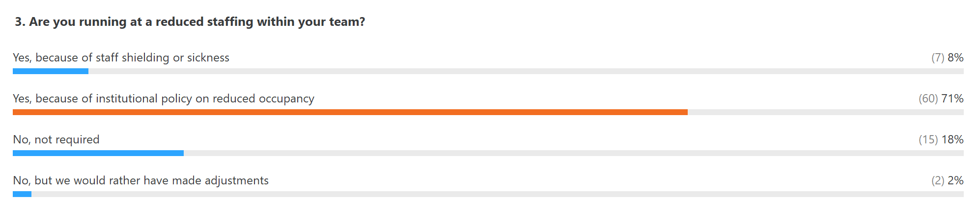
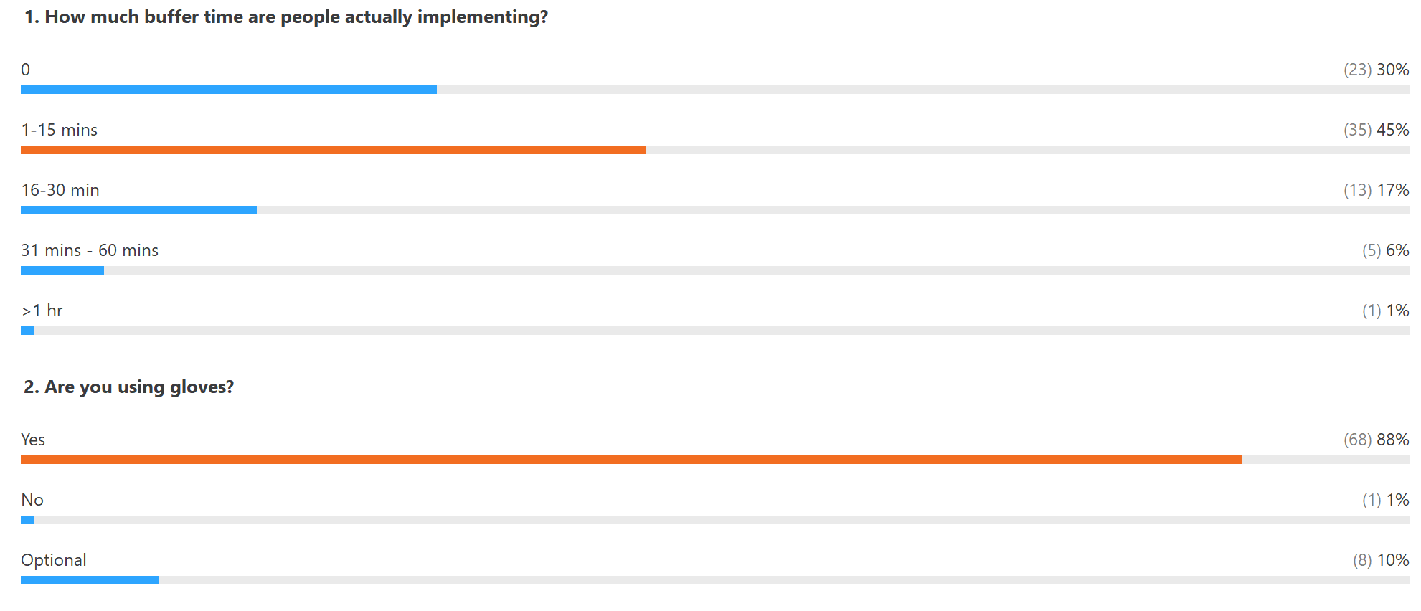
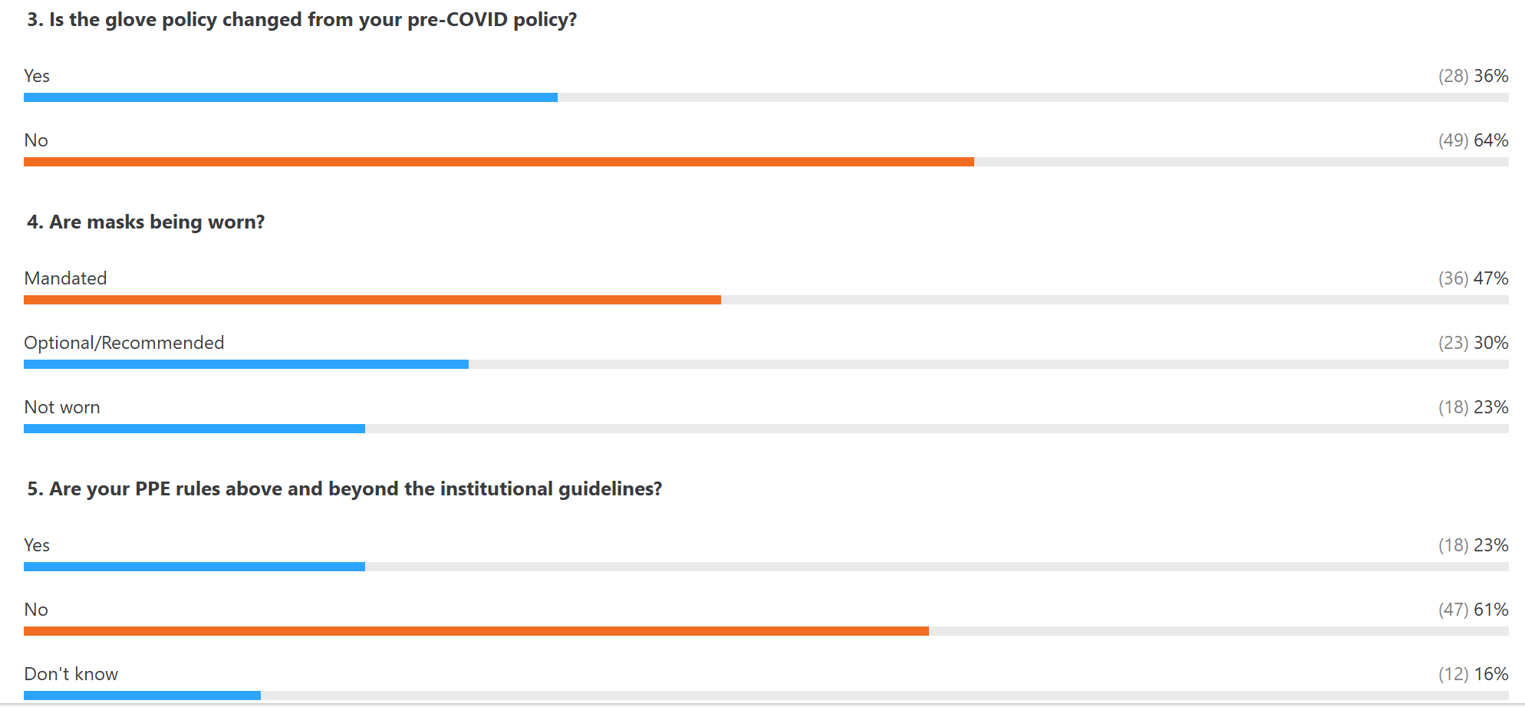

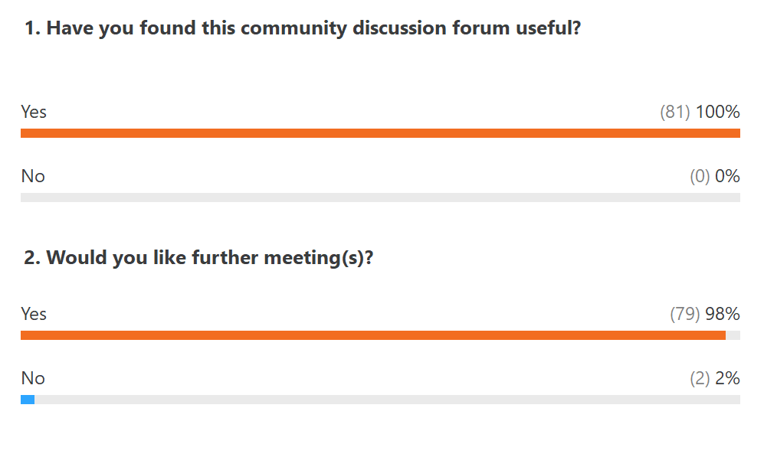

1 - Does your Institution suggest that COVID-19 research should be prioritised over other research?

Yes – 38%
No – 42%
Don’t know – 20%

2 - Are facility staff responsible for deciding whether some users should receive priority access to the cytometers?

Yes – 45%
No – 40%
Not sure – 15%
3 - If we choose to prioritize for cytometry and/or service work, on what basis?

Check all that you think should be prioritised
Manuscripts under final revision – 66%
Manuscripts close to submission – 33%
Students finishing their MSc/PhD – 61%
Postdocs finishing their position and moving on to another job – 48%
Grants about to end – 42%
Preliminary data for grant applications – 21%
Animal work (vs. cell culture) – 45%
Biggest users (“loyal” user award) 6%
Internal vs. external – 43%
“Squeaky wheel” – he/she who shouts the loudest – 4%

4 - Is your facility currently open?

Yes, only for COVID – 14%
Yes, open (with COVID-19 restrictions in place) – 67%
No, but we will re-open in the next week – 7%
No, and we will not re-open in the next week – 12%

5 - For those that have reopened, how have things gone?

Easier in practice than I expected – 17%
More challenging than I expected – 23%
As I expected – 32%
N/A – 29%

6 - Are you running at a reduced staffing within your team?

Yes, because of staff shielding or sickness – 8%
Yes, because of institutional policy on reduced occupancy – 71%
No, not required - 18%
No, but we would rather have made adjustments - 2%

7 - How much buffer time are people actually implementing?

0 – 30%
1-15 mins – 45%
16-30 min – 17%
31 mins - 60 mins – 6%
>1 hr – 1%

8 - Are you using gloves?

Yes – 88%
No – 1%
Optional – 10%

9 - Is the glove policy changed from your pre-COVID policy?

Yes – 36%
No – 64%

10 - Are masks being worn?
Mandated – 47%
Optional/Recommended – 30%
Not worn – 23%

11- Are your PPE rules above and beyond the
institutional guidelines?

Yes – 23%
No – 61%
Don’t know – 16%

